Date: 19/6/2018

Lab Assignment 1

**QUESTION:**

Implement a GUI based program which accepts the complaints from customers for their personal computer or laptops. Create a class Complaint which will have data members like complaint id, customer name, customer address, complaint and status. Add the complaint to the database. If the complaint of the customer is resolved, it should be added to customer’s history. If the complaint is not completely resolved the status of the complaint should be changed.

**PROGRAM:**

1. **MainPage.java**

private void jButton3ActionPerformed(java.awt.event.ActionEvent evt) {

this.setVisible(false);

new ComplaintForm().setVisible(true);

}

private void jButton4ActionPerformed(java.awt.event.ActionEvent evt) {

this.setVisible(false);

new AdminForm().setVisible(true);

}

private void jButton5ActionPerformed(java.awt.event.ActionEvent evt) {

this.setVisible(false);

new Output().setVisible(true);

}

**Output:**

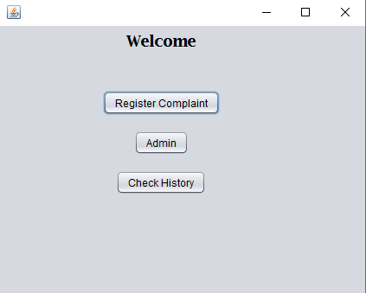

1. **ComplaintForm.java**

private void jButton1ActionPerformed(java.awt.event.ActionEvent evt) {

custid = jTextField7.getText();

Complaint_Desc = jTextArea1.getText();

String stat = "Registered";

try {

UserData.cid = custid;

Class.forName("net.ucanaccess.jdbc.UcanaccessDriver");

Connection con = DriverManager.getConnection("jdbc:ucanaccess://D:/Adv. java/Customer_Complaint.accdb");

SimpleDateFormat MyDate = new SimpleDateFormat("dd/MM/yyyy HH:mm:ss");

Date date;

date = new Date();

PreparedStatement ps=con.prepareStatement("insert into Complaint_master (customer_id,complaint_desc,status,DateTime) values(?,?,?,?);");

ps.setString(1,UserData.cid);

ps.setString(2, Complaint_Desc);

ps.setString(3,stat);

ps.setString(4, MyDate.format(date));

ps.executeUpdate();

JOptionPane.showMessageDialog(this, "Resgistraion Successful");

System.out.println("Inserted successfully");

this.setVisible(false);

new ComplaintForm().setVisible(true);

}

catch(Exception e)

{

System.out.println(e);

}

}

private void jButton2ActionPerformed(java.awt.event.ActionEvent evt) {

this.setVisible(false);

new MainPage().setVisible(true);

}

private void jRadioButton2ActionPerformed(java.awt.event.ActionEvent evt) {

this.setVisible(false);

new CustomerRegist().setVisible(true);

}

private void jButton3ActionPerformed(java.awt.event.ActionEvent evt) {

Complaint_Desc = jTextArea1.getText();

try {

Class.forName("net.ucanaccess.jdbc.UcanaccessDriver");

Connection con = DriverManager.getConnection("jdbc:ucanaccess://D:/Adv. java/Customer_Complaint.accdb");

Statement st = con.createStatement();

String sql = "select * from Customer_master where customer_id = '"+jTextField7.getText().trim()+"'";

ResultSet rs = st.executeQuery(sql);

if(rs.next() == false){

JOptionPane.showMessageDialog(this, "Please Register First!");

}

else{

do{

jTextField3.setText(rs.getString("customer_name"));

jTextField5.setText(rs.getString("customer_address"));

jTextField6.setText(rs.getString("customer_tel_no"));

}while(rs.next());

}

}

catch(Exception e) {

System.out.println(e);

}

}

**Output:**

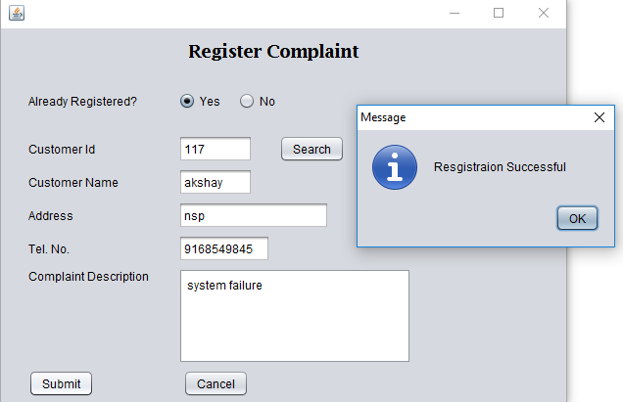

1. **AdminForm.java**

private void jButton1ActionPerformed(java.awt.event.ActionEvent evt) {

String custid = jTextField1.getText();

String compid = jTextField2.getText();

String st = jComboBox1.getSelectedItem().toString();

try{

Class.forName("net.ucanaccess.jdbc.UcanaccessDriver");

Connection con = DriverManager.getConnection("jdbc:ucanaccess://D:/Adv. java/Customer_Complaint.accdb");

Statement sqlf = con.createStatement();

ResultSet rs = sqlf.executeQuery("select * from Complaint_master where complaint_id = '"+compid+"' and customer_id='"+custid+"'");

while(rs.next()){

String complaint_id = rs.getString("complaint_id");

String customer_id = rs.getString("customer_id");

String complaint_desc = rs.getString("complaint_desc");

String status = rs.getString("status");

String DateTime = rs.getString("DateTime");

if(complaint_id.equals(compid) & customer_id.equals(custid) & st.equals("Pending")){

Statement stmt = con.createStatement();

stmt.executeUpdate("update Complaint_master set status = 'Pending' WHERE customer_id = '"+ custid + "' AND complaint_id = '"+ compid +"'");

JOptionPane.showMessageDialog(this, "Status Updated Successfully!" + st);

this.setVisible(false);

new MainPage().setVisible(true);

}

else if(complaint_id.equals(compid) & customer_id.equals(custid) & st.equals("Resolved")){

UserData.cid = customer_id;

PreparedStatement sqli = con.prepareStatement("insert into Customer_history (customer_id, complaint_id, complaint_desc, datetime) values(?,?,?,?)");

sqli.setString(1, custid);

sqli.setString(2, compid);

sqli.setString(3, complaint_desc);

sqli.setString(4, DateTime);

sqli.executeUpdate();

Statement std = con.createStatement();

String sqld = "delete from Complaint_master where customer_id = '"+ custid +"' AND complaint_id = '"+ compid +"'";

std.executeUpdate(sqld);

JOptionPane.showMessageDialog(this, "Status Updated Successfully!" + st);

this.setVisible(false);

new MainPage().setVisible(true);

}

else{

JOptionPane.showMessageDialog(this, "no records found!");

}

System.out.println(complaint_id);

System.out.println(customer_id);

System.out.println(complaint_desc);

System.out.println(status);

System.out.println(DateTime);

System.out.println(st);

}

}

catch(Exception e){

System.out.println(e);

}

}

private void jButton2ActionPerformed(java.awt.event.ActionEvent evt) {

this.setVisible(false);

new MainPage().setVisible(true);

}

**Output:**

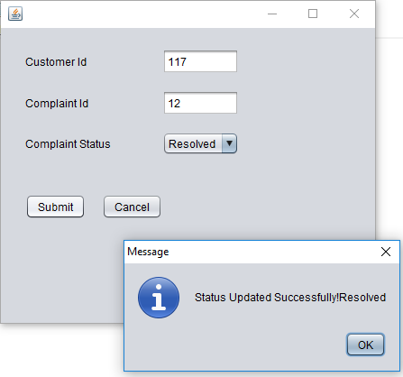

1. **UserData.java**

package customercare;

public class UserData {

public static String cid;

}

1. **CustomerRegist.java**

private void jButton2ActionPerformed(java.awt.event.ActionEvent evt) {

this.setVisible(false);

new MainPage().setVisible(true);

}

private void jButton1ActionPerformed(java.awt.event.ActionEvent evt) {

String dup = "true";

try {

Class.forName("net.ucanaccess.jdbc.UcanaccessDriver");

Connection con = DriverManager.getConnection("jdbc:ucanaccess://D:/Adv. java/Customer_Complaint.accdb");

Statement st = con.createStatement();

String sql = "select * from customer_master;";

ResultSet rs = st.executeQuery(sql);

while(rs.next()){

if(rs.getString("customer_name").equalsIgnoreCase(jTextField1.getText()) && rs.getString("customer_address").equalsIgnoreCase(jTextField2.getText()) && rs.getString("customer_tel_no").equalsIgnoreCase(jTextField3.getText())){

JOptionPane.showMessageDialog(null, "User Already Registered");

dup = "false";

}

}

if("true".equals(dup)){

PreparedStatement ps=con.prepareStatement("insert into Customer_master (customer_name,customer_address,customer_tel_no) values(?,?,?);",Statement.RETURN_GENERATED_KEYS);

ps.setString(1,jTextField1.getText());

ps.setString(2,jTextField2.getText());

ps.setString(3,jTextField3.getText());

ps.executeUpdate();

JOptionPane.showMessageDialog(null, "Registered successfuly");

this.setVisible(false);

new MainPage().setVisible(true);

}

}

catch(Exception e)

{

System.out.println(e);

}

}

**Output:**

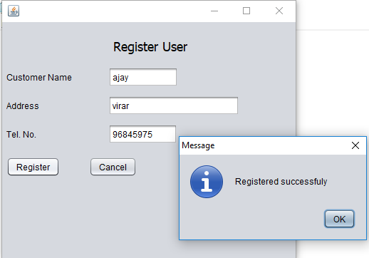

1. **Output.java**

public class Output extends javax.swing.JFrame {

public Output() {

initComponents();

DisplayData();

@SuppressWarnings("unchecked")

private void jButton1ActionPerformed(java.awt.event.ActionEvent evt) {

this.setVisible(false);

new MainPage().setVisible(true);

}

private void DisplayData() {

try{

Class.forName("net.ucanaccess.jdbc.UcanaccessDriver");

Connection con = DriverManager.getConnection("jdbc:ucanaccess://D:/Adv. java/Customer_Complaint.accdb");

Statement st = con.createStatement();

ResultSet rs = st.executeQuery("select * from Customer_history");

ResultSetMetaData md = rs.getMetaData();

jTable1.setModel(DbUtils.resultSetToTableModel(rs));

}

catch(Exception e){

System.out.println(e);

}

}

}

**Output:**

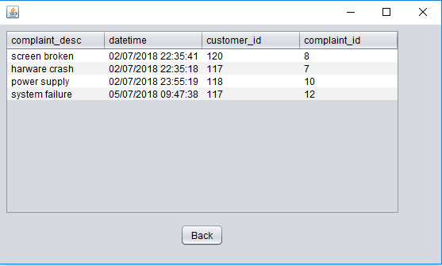

**Database:**

1. **Complaint_master:**

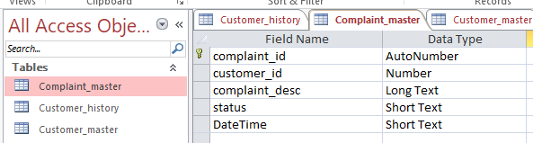

1. **Customer_history**

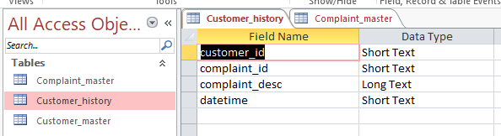

1. **Customer_master**

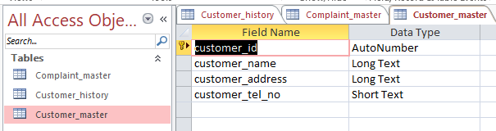

1. **Relationship**

